**Period-1 Vanilla JavaScript, Es-next, Node.js, Babel + Webpack and TypeScript-1**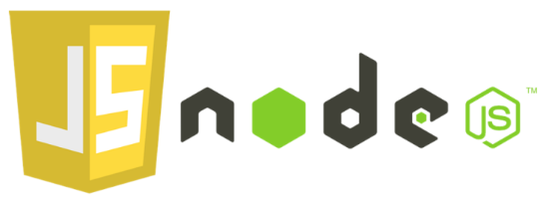

Note: This description is too big for a single exam-question. It will be divided up into several smaller questions for the exam

Explain and Reflect:

* Explain the differences between Java and JavaScript + node. Topics you could include:
  + that Java is a compiled language and JavaScript a scripted language

**Java skal compiles før det det kan afvikles. Hvorimod et scripted language kan afvikles on the go. Javascript f.eks. som bruges til webapplikationer.**

* + Java is both a language and a platform

**Java kører i Java virtuel machine. Også kaldet (JVM). I mens JavaScript kører out direkte i webbrowseren.**

* + General differences in language features.

**Java er meget stærkt typesprog. Hvorimod JavaScript er i en helt anden boldgade.**

* + Blocking vs. non-blocking

**Hvis man ”blokerer” noget, vil stakken ikke blive kørt før den blokerede kode er kørt.**

* Explain generally about node.js, when it “makes sense” and *npm*, and how it “fits” into the node echo system.
* Explain about the Event Loop in JavaScript, including terms like; blocking, non-blocking, event loop, callback queue and "other" API's. Make sure to include why this is relevant for us as developers.
* What does it mean if a method in nodes API's ends with xxxxxx**Sync**?
* Explain the terms JavaScript Engine (name at least one) and JavaScript Runtime Environment (name at least two)
* Explain (some) of the purposes with the tools *Babel* and *WebPack and how they differ from each other*.       Use examples from the exercises.

Explain using sufficient code examples the following features in JavaScript (and node)

* Variable/function-Hoisting
* *this* in JavaScript and how it differs from what we know from Java/.net.
* Function Closures and the JavaScript Module Pattern
* User-defined Callback Functions (writing functions that take a callback)
* Explain the methods map, filter and reduce
* Provide examples of user-defined reusable modules implemented in Node.js (learnynode - 6)
* Provide examples and explain the es2015 features: let, arrow functions, this, rest parameters, destructuring objects and arrays,   maps/sets etc.
* Provide an example of ES6 inheritance and reflect over the differences between Inheritance in Java and in ES6.
* Explain and demonstrate, how to implement event-based code, how to emit events and how to listen for such events

ES6,7,8,ES-next and TypeScript

* Provide examples with es-next, running in a browser, using Babel and Webpack
* Explain the two strategies for improving JavaScript: Babel and ES6 + ES-Next, versus Typescript. What does it require to use these technologies: In our backend with Node and in (many different) Browsers
* Provide **examples** to demonstrate the benefits of using TypeScript, including, types, interfaces, classes and generics
* Explain how we can get typescript code completion for external imports.
* Explain the ECMAScript Proposal Process for how new features are added to the language (the TC39 Process)

**Callbacks, Promises and async/await**

Explain about (ES-6) promises in JavaScript including, the problems they solve, a quick explanation of the Promise API and:

* ~~Example(s) that demonstrate how to avoid the callback hell  (“Pyramid of Doom")~~
* Example(s) that demonstrate how to implement **our own** promise-solutions.
* Example(s) that demonstrate error handling with promises
* Example(s) that demonstrate how to execute asynchronous (promise-based) code in **serial** or **parallel**

Explain about JavaScripts **async/await**, how it relates to promises and reasons to use it compared to the plain promise API.

Provide examples to demonstrate

* Why this often is the preferred way of handling promises
* Error handling with async/await
* Serial or parallel execution with async/await.

Se the exercises for Period-1 to get inspiration for relevant code examples